DOKUMENTASI TUGAS AKHIR DATA MINING 4408

NIM : A11.2021.13434  
NAMA : Nico Darmawan

Code :

import matplotlib.pyplot as plt

import matplotlib.ticker as tick

import pandas  as pd

import numpy   as np

import seaborn as sns

import re

import os

**Load Data**

df_items = pd.read_csv('20191002-items.csv')

df_reviews = pd.read_csv('20191002-reviews.csv')

print('shape : {}'.format(df_items.shape))

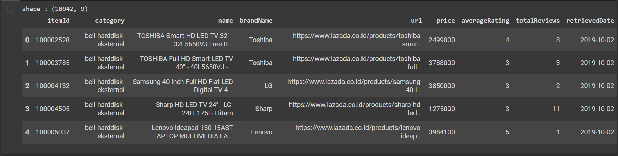df_items.head()

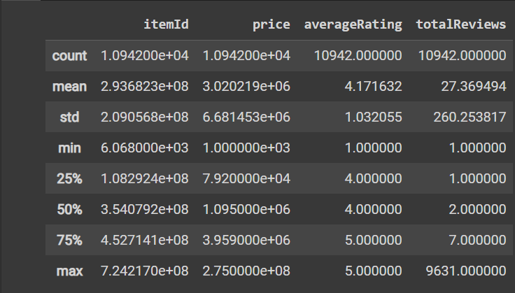df_items.describe()

print('shape : {}'.format(df_reviews.shape))

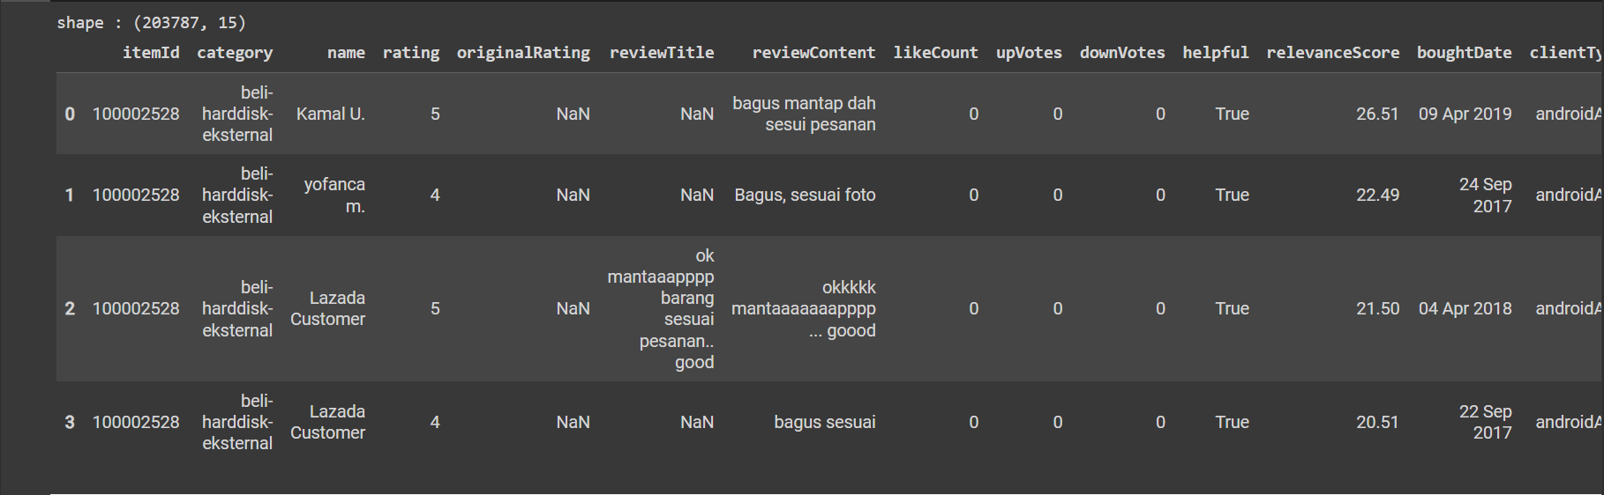df_reviews.head(4)

print('\nDataset of Reviews product \n')

print('Shape dataset:', df_reviews.shape)

print('\nInfo dataset:')

print(df_reviews.info())

print('\nDescriptive Statistic:\n', df_reviews.describe())

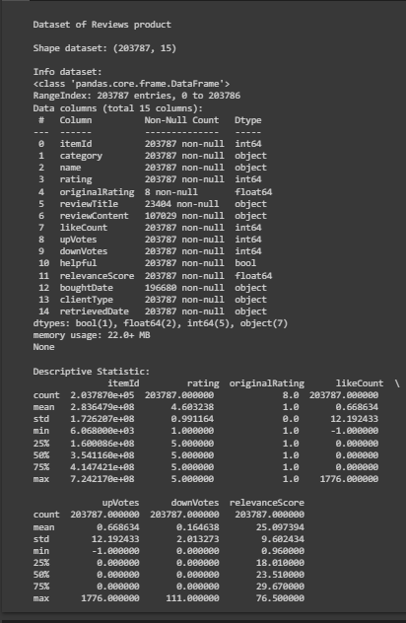

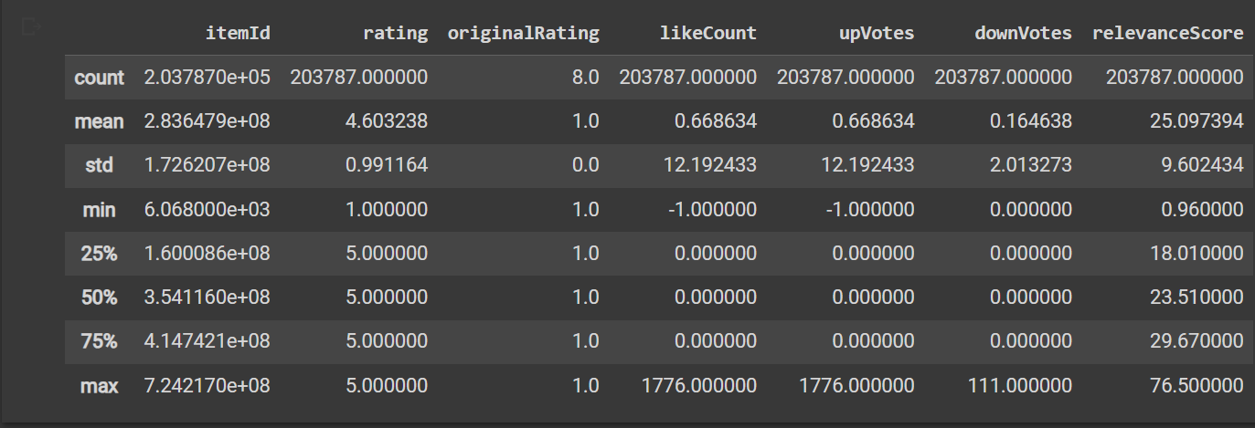df_reviews.describe()

df_items.category.value_counts()

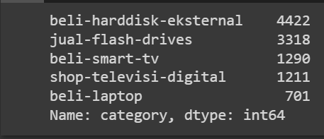

df_items['brandName'].unique()

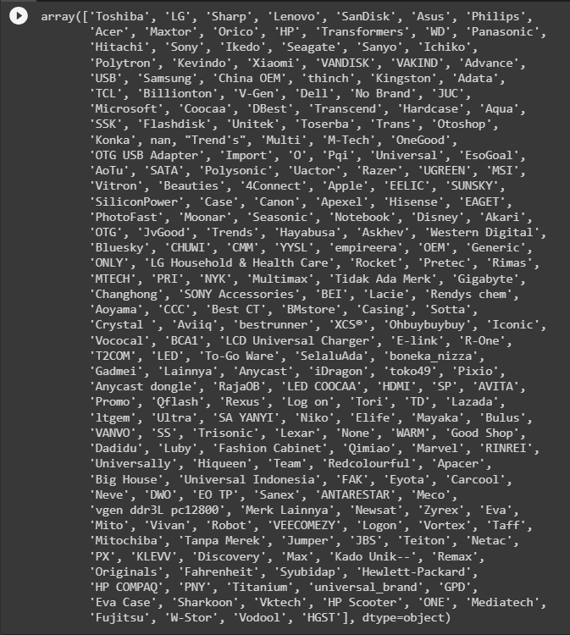

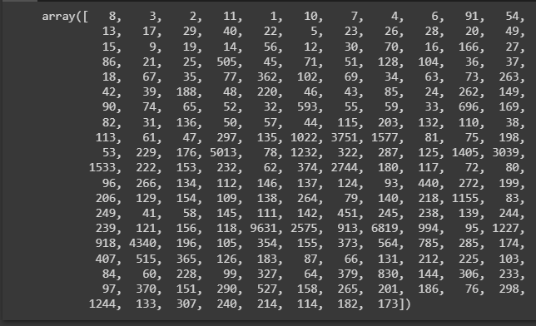df_items['totalReviews'].unique()

kategori_items = ['A','B','C','D','E']

data = [4422 , 3318 , 1290 , 1211 , 701]

warna = ['pink', 'cyan', '#e03364', 'yellowgreen','skyblue']

plt.pie(data,

       labels  = kategori_items,

       colors  = warna,

       autopct = '%1.1f%%',

       startangle=90

       )

plt.legend()

plt.title ('items_df')

plt.show()

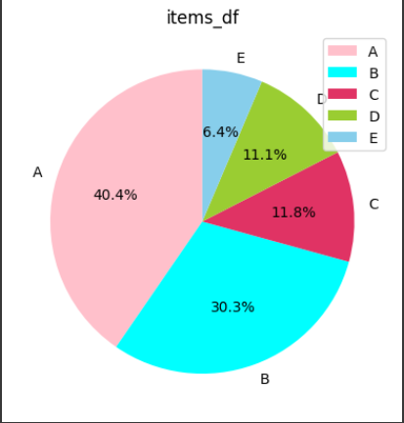

df_reviews.describe()

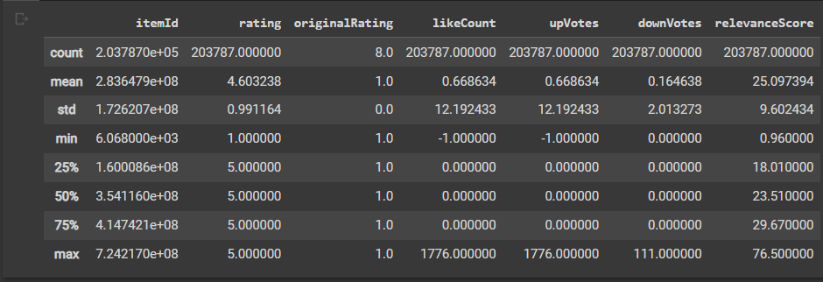

df_items.category.value_counts()

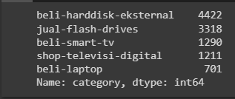

df_items = df_items.head(10)

fig = plt.figure(figsize=(7,3))

ax  = fig.add_axes([0,0,1,1])

ax.set_xlabel('brandName')

ax.set_ylabel('totalReviews')

ax.bar(df_items['brandName'],df_items['totalReviews'])

plt.show()

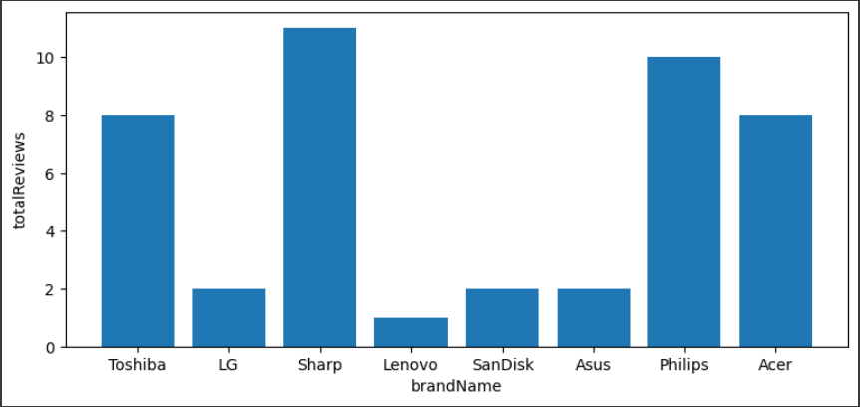

df_items = df_items.groupby('brandName').sum()['averageRating'].reset_index()

fig = plt.figure()

ax  = fig.add_axes([0,0,1,1])

ax.axis('equal')

ax.set_title(label= 'Rating rata-rata pelanggan menilai nama product')

ax.pie(df_items['averageRating'],labels = df_items['brandName'],autopct='%1.2f%%')

plt.show()

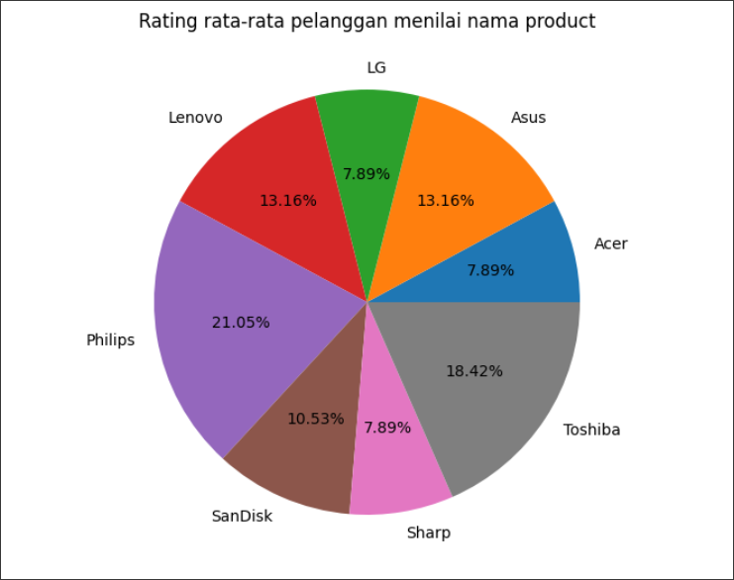

plt.hist(df_items['brandName'].dropna(), bins=20)

plt.show()

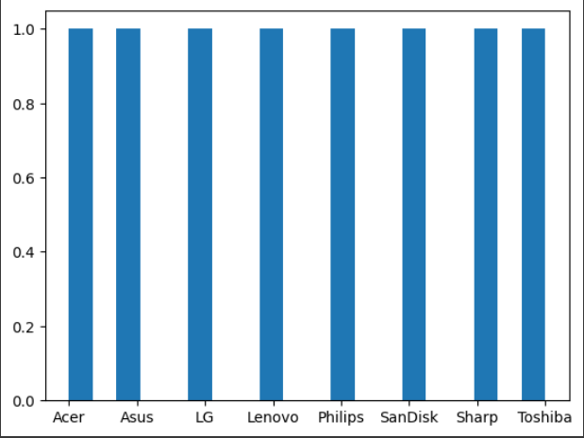

df_reviews.columns



cat = ['relevanceScore']

for col in cat:

  plt.figure(figsize=(10,3))

  plt.scatter(df_reviews.index,df_reviews[col])

  plt.title(col)

  plt.show()

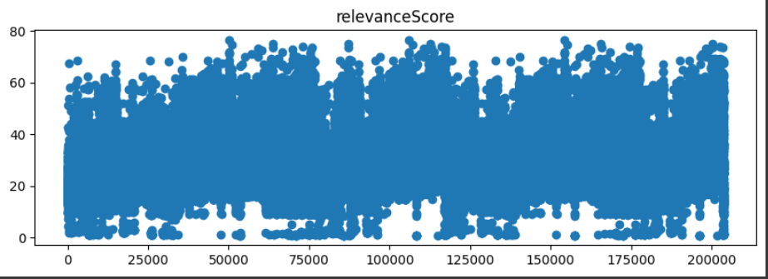

plt.figure(figsize=(15,6))

sns.pointplot(x="category", y="relevanceScore", hue="rating", data=df_reviews)

plt.show()

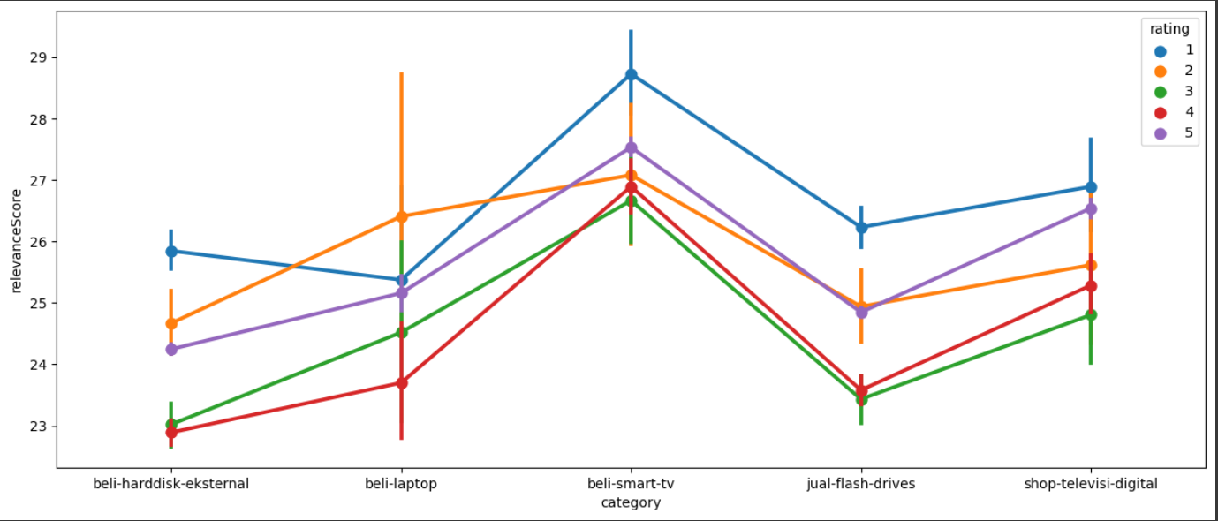

plt.figure(figsize=(15,6))

sns.pointplot(x="clientType", y="relevanceScore", hue="rating", data=df_reviews)

plt.show()

